1000lb CLUB / 600lb CLUB
- To qualify, participants must submit videos of successful repetitions in conventional barbell deadlift, bench press and back squat. The successful single repetitions of each should sum 1000+lbs for male or 600+ for females.
- Attempts in all three must be made in the same day, within a 3-hour window.
- Traditionally, the back squat is performed first, followed by bench then deadlift, however participants may attempt lifts in any order they choose, so long as the attempts are made within a 3-hour window.
- Safety bars and/or spotters are strongly encouraged for near maximum or maximum attempts. Individuals participate at their own risk. If a single lift is failed three times, participants are strongly encouraged to stop and re-attempt another day.
- All three lifts submitted must be successful lifts performed within a
3-hour window for consideration.
- Barbell collars are mandatory on all three lifts or the attempts will not be valid.
Participants may use belts, knee sleeves, wrist wraps, lifters, etc.
- RESTRICTED ACCESSORIES
Supportive Gear offering the lifter an advantage as defined by USAPL Equipped Powerlifting guidelines will not be accepted for consideration:
  - Supportive Singlets
  - Bench Shirts
  - Knee Wraps
  - Lifting Hooks (see photo)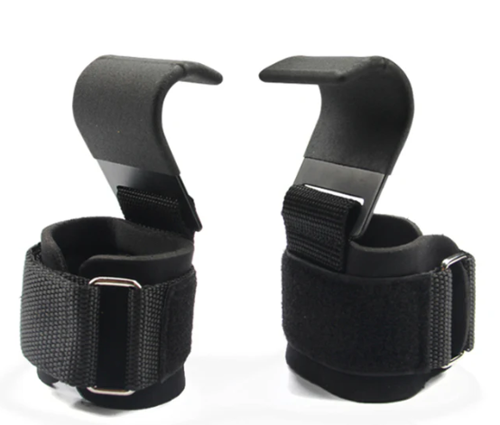
  - Lifting Straps (see photo)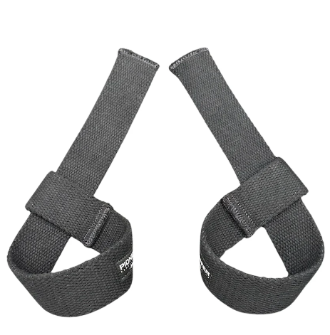
Fitness Center Dress Codes should be adhered to at all times.
- Proper fitness footwear:
  - Close-toed, Closed-heeled, or Rubber-soled Shoes
  - Powerlifting moccasins are acceptable as they are in accordance with the aforementioned.
VIDEO SUBMISSIONS
Recorded from a ¾ viewpoint, with the individual’s entire body, barbell, loaded weights and full movement of the lift visible.
- Loaded weights should be clearly visible within the entire duration of video; unedited.
- Lift or loaded weights recorded immediately following the lift on the unedited video.
- The use of a 35 or 45lb bar should be noted verbally or visibly via the video submission.
BACK SQUAT
- Attempts should begin with hips and knees fully extended, with individual motionless and erect.
- At the bottom of the squat, the crease of the lifter’s hips should clearly pass below the top of the knee, otherwise known as breaking parallel. The lifter’s femur should move past parallel with the floor.
- Hips and knees should be fully extended at the top of the attempt, with the barbell clearly in control at standing.
BENCH
- Lifters may receive assistance removing the bar from the lifting rack, however the attempt should start clearly unassisted and untouched by spotter or other individuals.
Ensure the bar does not begin descending until clear from assistance.
- The lifters head, shoulders and glutes should remain in contact with the bench at all times during the attempt. Feet must remain in contact with the floor at all times throughout the lift.
- Submissions should use a “thumbs around” grip. Any other grip, ie. thumbs on the same side of the bar as the rest of the fingers, will not be considered and will be cause for immediate disqualification.
- At the bottom of the lift, the bar must lower to the chest or abdominal area, making contact below the clavicle (bar may not touch below the abdominal area). The bar may not touch anything such as a weightlifting belt that would shorten the range of motion for the lifter, ie. add additional material between lifter or bar to decrease the range of motion or cause advantage.
- The lifter must then return the bar to a finished position of extended elbows or straight arms. The bar must clearly be held motionless in this position before returning to the rack. Bench presses that move through extension backwards into the rack, not showing clear control at the extended position, will be disqualified. Lifters may receive assistance with re-racking the bar, so long as the extended finish position is clearly displayed before the bar is touched by another individual.
DEADLIFT
- The barbell should begin from the ground, horizontally in front of the lifter, level with the lifter’s feet.
Elevation of any kind is not permitted for the purposes of this leaderboard submission.
- Any grip is acceptable, so long as the bar is held within both hands. Sumo or conventional deadlifts are acceptable.
- Hips and knees should be extended at the top of the attempt, with shoulders clearly behind the barbell.
- Any support of the barbell on the thighs on the upwards motion of the attempt will be disqualified. Hitching or continuous movement is acceptable, so long as the barbell is not supported by the thighs.
- Control of the barbell past the knees on the descent is not required, however lifters must clearly show control at full extension or standing, prior to releasing the barbell.

