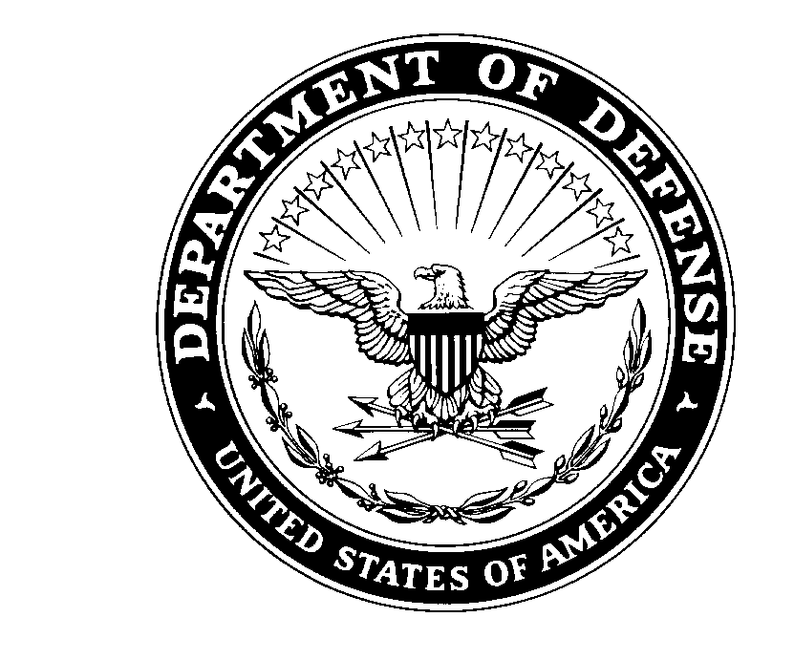
IMHM-ZA 21 December 2022

MEMORANDUM FOR RECORD

SUBJECT: Letter of Release for USAG Humphreys BOSS Inclusion Cup Bowling Tournament

1. The USAG Humphreys BOSS Program will be hosting a bowling tournament on 31 January from 1400-UTC at the Downtown Lanes. Brigade teams of 2 males, 2 females, and 2 KATUSAs will see who can get the highest combined score.

2. Participants are to be allowed adequate time to arrive, therefore a letter of release authorizing Soldiers’ early departure from their duties is required before they can sign up for the event.

3. Schedule for USAG Humphreys BOSS Inclusion Cup Bowling Tournament is as follows:

31 January:
Event 1400-UTC

4. The following Soldier has agreed to participate:
(RANK / NAME / BRIGADE)

(EMAIL / PHONE NUMBER / MALE / FEMALE / KATUSA)

5. Soldiers are to be allotted at least one hour prior to the start of the event venue setup to be able to change into appropriate attire, as well as to report to the event within an adequate time.

6. Signature of this form constitutes participation of said Soldier for the USAG Humphreys BOSS Inclusion Cup Bowling Tournament, and grants said Soldier the time specified to participate.

7. Upon submission of memorandum, the Soldier’s place of duty will be the specified location and time of the event.

8. POC for this event is BOSS President SPC Holmes, Ian J. at DSN: 757-1647 and ian.j.holmes.mil@army.mil.

FOR THE COMMANDER:

_________________________ _________________________
CPT, USA 1SG, USA

_________________________ _________________________
(SIGNATURE) (SIGNATURE)

_________________________ _________________________
(Unit Contact & Phone Number) (First line email)

