- Child Abuse and Neglect on the MWR Academy FY26: https://lms.mwr.army.mil/ContentDetails.aspx?id=F39884E5414743A19B0A7656D7590DD0
  - This is an annual training, which means that if you completed the training on Jan 1, 2025 it will expire on Jan 1, 2026. Therefore, you will have to complete it by Dec 31, 2024.
  - If you have an account, then proceed to login.
  - If you do not have an account create new account:
    - Organization: CYSS Support Positions
    - Find Job Title: CYSS Volunteers (Search Type: Exact Phrase)
    - Find Manager: Imara Anderson - CYSS Volunteers
    - Installation: USAG Humphreys
    - Time Zone: (UTC+9:00) Seoul
  - In Catalog, search FY26 Accountability and Supervision in CYS Child Abuse Prevention, Identification, and Reporting
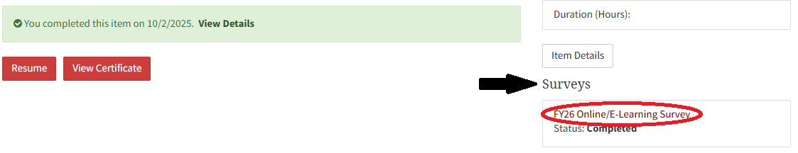
  - Once you complete the training, make sure to complete the survey (if applicable). Otherwise, the system won’t generate a certificate until this step is completed.

  - Click “View Certificate” or hover over the initials of your name located in the right-hand corner and click account. You should see a light grey box in the right corner that says "# completed content". Click on that, then find the training and click click “View Certificate”.

- NAYS Sport Specific and NAYS Concussion : nays.org
  - All training courses are paid for by Youth Sports. They will be placed on your NAYS account once you have created one.
  - If you have an account, then proceed to login.
  - If you do not have an account, then create new account:
    - Make sure the Organization Affiliations are under ‘USAG Humphreys’ and the Role is ‘NAYS Coach’.
  - Complete the following trainings:
    - Concussion training - annually
    - Coaching Youth Sports - once
    - Basic Youth Sports Safety and First Aid Training - once
    - Sports Specific (ex. Coaching Youth Basketball Under 10, Coaching Youth Flag Football, Coaching Youth Volleyball, etc.) - every 3 years
***There are no Sports Specific training courses for Track & Swim. Please complete any sport that you want to potentially coach in the future or any sport that may work on similar skills as track and/or swim***
- CPR + First Aid & AED:
  - This is a hybrid training. You will need to complete the online portion FIRST, then complete the in-person portion (a.k.a. Competency Check) with our instructor.
  - If you are already certified (ex. BLS, CLS), please email your certification and you will be exempt from this requirement. Please note that this training must be completed every 2 years.
  - If you are NOT certified:
    - You must send an email to usarmy.humphreys.imcom.mbx.fmwr-youth-sports-fitness@army.mil including your full name, phone number, and email address.
    - Our CPR instructor will place you in an online training class and you will receive an automated email from Salesforce Automation Account with further instructions to follow.
    - Once you complete the online portion, please contact our CPR instructor to schedule the Competency Check (the in-person portion). Once this portion is completed, the instructor will purchase the certificate through Red Cross, and you will certified for 2 years.
- Coach Orientation and Bloodborne Pathogen
  - Both trainings will be scheduled by Youth Sports Team Member and various dates will be sent out to attend the trainings. Both trainings will occur on the same day and take roughly an hour to complete. Please ask our Sport Specialists for the upcoming dates.

