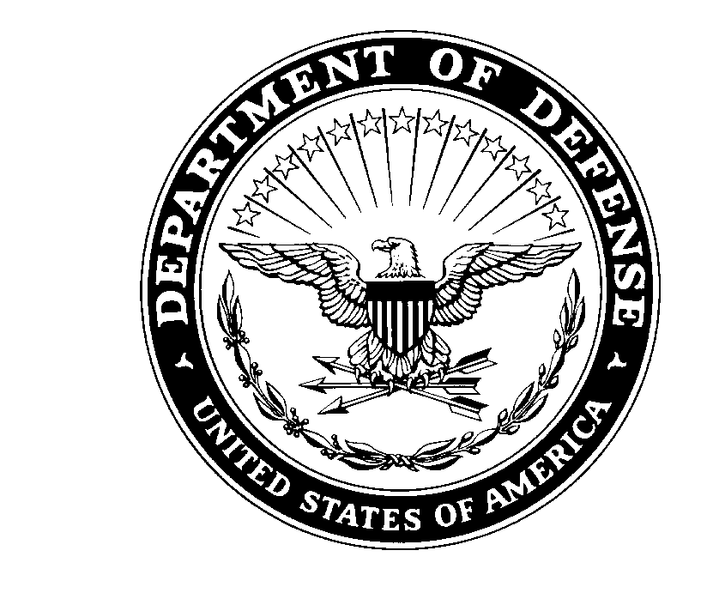
IMHM-ZA 21 December 2022

MEMORANDUM FOR RECORD

SUBJECT: Letter of Release for USAG Humphreys BOSS ASAP Ambassador Training.

1. The USAG Humphreys BOSS Program and ASAP are creating a program to equip junior enlisted Soldiers with the skills and knowledge necessary to combat substance use disorders as well as get Soldiers affected by them the help they need. ASAP staff and subject matter experts will facilitate training in FY23 at the Hub (BLDG #501).

2. Participants are to be allowed adequate time to arrive, therefore a letter of release authorizing Soldier’s early departure from their duties is required before Soldiers can sign up for the event.

3. Schedule for ASAP Ambassador Courses are as follows (circle or highlight dates you will participate):

QTR 2 - Sign-up: 19NOV22-08MAR23 / Course: 13MAR23-17MAR23 (0900-1700 @ BLDG #501)
QTR 3 - Sign-up: 18MAR23-07JUN23 / Course: 12JUN23-16JUN23 (0900-1700 @ BLDG #501)
QTR 4 - Sign-up: 17JUN23-06SEP23 / Course: 11SEP23-15SEP23 (0900-1700 @ BLDG #501)

4. The following Soldier has agreed to volunteer:
(RANK / NAME / BRIGADE)

(EMAIL / PHONE NUMBER)

5. Soldiers are to be allotted at least one hour prior to the start of the event venue setup to be able to change into appropriate attire, as well as to report to the event within an adequate time.

6. Signature of this form constitutes support of said Soldier for USAG Humphreys BOSS ASAP Ambassador Training, and grants said Soldier the time specified to volunteer.

7. Upon submission of memorandum, Soldier’s place of duty will be specified location and time of event.

8. Primary POC for this event is BOSS President SPC Holmes, Ian J. at DSN: 757-1647 and ian.j.holmes.mil@army.mil. Secondary POC for this event is BOSS Vice President SPC Gano, Austin M. at DSN: 757-1647 and email is austin.m.gano.mil@army.mil.

FOR THE COMMANDER:

_________________________ _________________________
CPT, USA 1SG, USA

_________________________ _________________________
(SIGNATURE) (SIGNATURE)

_________________________ _________________________
(Unit Contact & Phone Number) (First line email)

